

**VA: Health and Benefits Mobile App**

Version 5.0  
Launch: 01/31/2023

Revision History

| Date | Version | Description | Author |
| --- | --- | --- | --- |
| 11/5/2021 | 3.0 | Added VA Vaccine Records functionality | Ashley Matthews |
| 3/10/2022 | 4.0 | Added Payments functionality (pg 29-30)  Update Home & Profile screens to include Payment option | Meko Hong/Brenda Rocha |
| 11/08/22 | 5.0 | Added Prescriptions functionality (pg 13-22) | Esther Kitavi |
|  |  |  |  |

VA Mobile App

Product Guide

*Table of Contents*

**Mobile App Overview** **4**

What is the VA Mobile app? 4

Who can use the VA Mobile App? 4

User Journey: How do users find a VA contact center phone number? 5

**VA Mobile App Functionality** **5**

Sign-in 5

Claims 9

Profile 11

Prescriptions 13

Appointments 22

Secure Messaging 25

VA Vaccine Records 27

Letters 28

Payments 30

General Errors 31

Known Issues 38

**Contact Center Escalation Path** **38**

## 

## 

## 

## **Mobile App Overview**

### **What is the VA Mobile app?**

The Office of the CTO launched a mobile app that leverages native mobile features to allow Veterans to check the status of their services and complete simple, transactional tasks quickly and easily across health and benefits.

The VA mobile app combines existing functionality across multiple VA websites in one convenient place. This guide provides a high-level overview of the app experience and outline the significant differences between the app and web functionality. For more detailed information on the specifics of each feature, please refer to the existing web product guides.

Through user interviews, high-fidelity usability testing, and collaborative design sessions, the team learned that Veterans would get the most value from the following features in a mobile app:

* **Biometric login:** Enable face, fingerprint, or iris biometrics as a more convenient method for authentication
* **Veteran Crisis Line**: Access the crisis line with SMS integration
* **Profile**: Review and edit personal information, including direct deposit information and disability rating
* **Claims & Appeals Status**: Review claim statuses and manage claims
* **Appointments**: Review or cancel appointments, integrated with native phone features such as their calendar and map apps
* **Secure Messaging**: Communicate with VA health providers directly through the app
* **VA Vaccine Records:** Review VA vaccine history
* **Letters**: Download common VA letters and documents
* **Payments:** Review payments made by the VA
* **Facility Locator**: Use phone location services to find the nearest VA facilities

**Demos**

[Abbreviated demo](https://www.youtube.com/watch?v=FVFJAuAQoO8)

[Extended version demo](https://www.youtube.com/watch?v=H5whpmeRD-M)

### **Who can use the VA Mobile App?**

To log into the VA Mobile App:

* Veterans must download the VA mobile app from the app store on their mobile device (Apple App Store or Google Play)
* Veterans must log in with their LOA3 credentials (ID.me, DS Logon, and MHV credentials are all supported)
* Users can use biometric login (Touch ID, Face ID, Face recognition, Fingerprint, Iris) to allow for fast and easy login. When a user successfully enables a biometric login, they can gain access to the app with face, fingerprint, or iris biometrics and this remains valid for 45 days. After 45 days, the user will need to log in with their VA credentials.
  + Use of biometrics on the device is optional; if the user decides to opt-out, they will need to re-login whenever they open the app.

### **User Journey: How do users find a VA contact center phone number?**

Unlike the VA.gov footer, where users have a base phone number to always call, there is no single VA Mobile App phone number that is always viewable for the users. Instead, users have access to a phone number when at a loose end of the experience - i.e., if no claims or messages appear for them in the app.

## **VA Mobile App Functionality**

#### **Sign-in**

The VA Mobile App supports three VA credentials (ID.me,Login.gov, MHV, and DS Logon) and must be LOA3. The sign-in experience for each credential type is a web view of the same workflow users would experience logging into va.gov or MHV. Users have an opportunity to opt into utilizing biometric login (face, fingerprint, or iris recognition) during the app onboarding process and within the app settings.

**For users with biometric login enabled:**

* App users remain logged into the app for 45 days. Within the 45-day period, the app will authenticate with their face, fingerprint, or iris recognition.
* Users will sign in via biometrics each time they open the app, but this will vary based on the user’s phone memory and whether there are apps are running in the background.
* After 45 days, users will need to re-authenticate by logging into the app with one of their VA credentials.
  + If the user previously opted into biometric login, their preference is saved, and they do not have to re-opt into biometrics.

**For users without biometric login enabled:**

* **If the user has a passcode set on their device:** the app prompts the user to enter a passcode, but users do not have to re-authenticate with username and password.
* **If the user does NOT have a passcode set on their device:** the app prompts the user to re-authenticate with their username and password each time they open the app.

**Resetting Passwords**

* As with VA.gov, passwords can only be rest by the identity providers (ID.me, Login.gov, DS Logon, or My HealtheVet).
* Currently, users venture outside the app when resetting passwords. Users will need to go back to the VA Mobile app and enter their new credentials to gain access after resetting a password.

**Sign-in Flow (utilizing ID.me credentials)**

| **Sign-in Screen 1** | **Sign-in Screen 2**  **(Part a)** | **Sign-in Screen 2**  **(Part b)** | **Sign-in Screen 3** |
| --- | --- | --- | --- |

*Note: users will note see the ‘Internal release for testing only’ message in Screen 1*

| **Sign-in Screen 4**    *Authentication loading screen* | **Sign-in Screen 5** | **Sign-in Screen 6** | **Sign-in Screen 7** |
| --- | --- | --- | --- |

#### 

| **Sign-in Screen 8**    *Loading screen* | **Sign-in Screen 9***Authentication loading screen* | **Sign-in Screen 10** | **Sign-in Screen 11**  *App loading screen* |
| --- | --- | --- | --- |

#### 

| **Onboarding Screen 1** | **Onboarding Screen 2** | **Onboarding Screen 3** | **Onboarding Screen 4** |
| --- | --- | --- | --- |

#### 

| **Onboarding Screen 5** | **Homepage Screen** |  |
| --- | --- | --- |

#### **Claims**

Within the app, users can view their claims and appeals information for existing claims. It is not currently possible to file new claims from the mobile app.

Claims Features:

* Using the claims functionality within the mobile app, a user can view all claim and appeal types:
  + Disability compensation
  + Veterans or Survivors Pension Benefits
  + Special monthly compensation
  + Dependency and Indemnity Compensation (DIC)
  + Burial allowance
* View closed claims and appeals details
  + All claim types will display from the past 365 days
* View Active claims
  + View steps completed of each claim
  + Flag when additional evidence is needed and allow users to upload and submit additional files in Step 3 of the claims process

To see claims, users should click on the Claims card on the homepage screen.

| **Homepage Screen** | **Claims Landing Page Screen** |
| --- | --- |

When a user clicks into an active claim, they can view the status of their claim, and more details about the claim.

| **Claims Status Screen**  **(Part 1)** | **Claims Status Screen**  **(Part 2)** | **Claims Details Screen** |
| --- | --- | --- |

#### **Profile**

App users will be able to view and edit their VA.gov profile information. Information updated on the app will also update in the user’s VA.gov profile.

* View and edit VA.gov profile
  + Disability Rating
  + Personal and contact information
    - Users can edit the same information on va.gov and the app
      * Date of birth
      * Gender
      * Mailing address (Note: users cannot remove a mailing address they have on file, which is the same experience on va.gov)
      * Home address
      * Phone numbers (home, work, mobile, fax)
      * Contact email address (may be different than the email used for signing in)
  + Military information
    - Period of service
  + Direct deposit information
    - Users can only see/edit disability compensation and pension benefits.
  + View Letters and documents
  + Payments
* Note: the web Profile has two other tabs of Account Security and Connected Apps that users can edit, but these aren’t included in the app.
* Manage app settings
  + To confirm or update the user’s sign-in email, they must go to the website where they manage their account information.
  + Configure biometric preference (Note: the text displayed for the biometric preference on the Settings page will dynamically match the device’s capabilities. If a user has biometrics completely turned off on their device, they will not see any biometric preferences.)
  + Share the app
    - Users can share the app via text message or email. Selecting this option brings up the user’s phone native sharing capabilities.

To view the user’s profile, users should click on the profile icon on the bottom navigation bar.

| **Homepage** | **Profile Screen** |
| --- | --- |

#### 

#### **Prescriptions**

In the VA Mobile: Health and Benefits App, users can: view their VA prescriptions, request refills of their eligible VA prescriptions, and view prescription tracking information. It is not currently possible to renew prescriptions in the app. This functionality is similar to the functionality found on the MHV website, and the RX Refill App.

**Prescription Features**

* View active and non-active prescriptions
  + Filter and sort prescriptions
  + View prescription details
* Request a refill of eligible prescriptions
* View pending (recently submitted, or refill in process) refills
* View trackable refills
  + View tracking information associated with tracked refills

**Getting to Prescriptions**

To view prescriptions, users can either click the:

1. The “Health Care” card on the home screen **or**
2. The “Health” tab on the bottom navigation bar

From there users can then click the “Prescriptions” card on the “Health care” screen

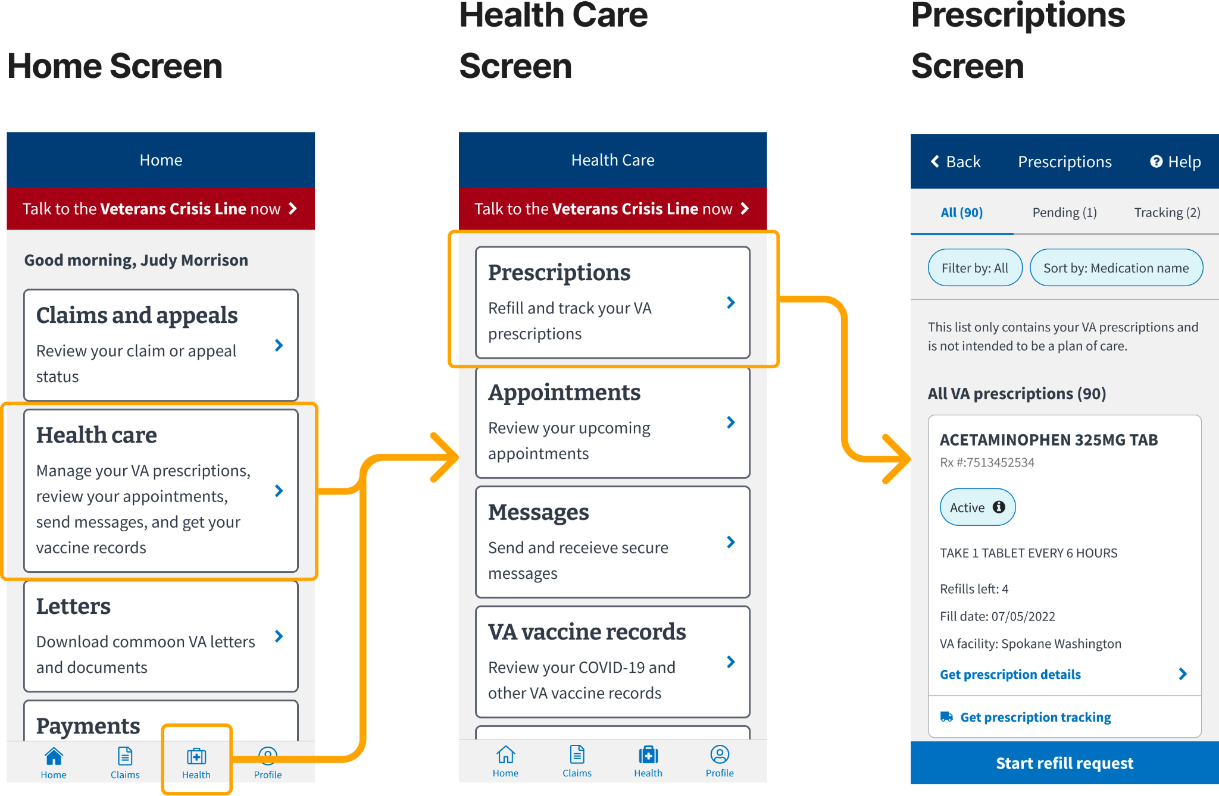

**Error Screens**

Error screens may appear while the user is using the app. Users should refresh the screen (if the button is present) or check back again later, as this may be due to upstream service issues.

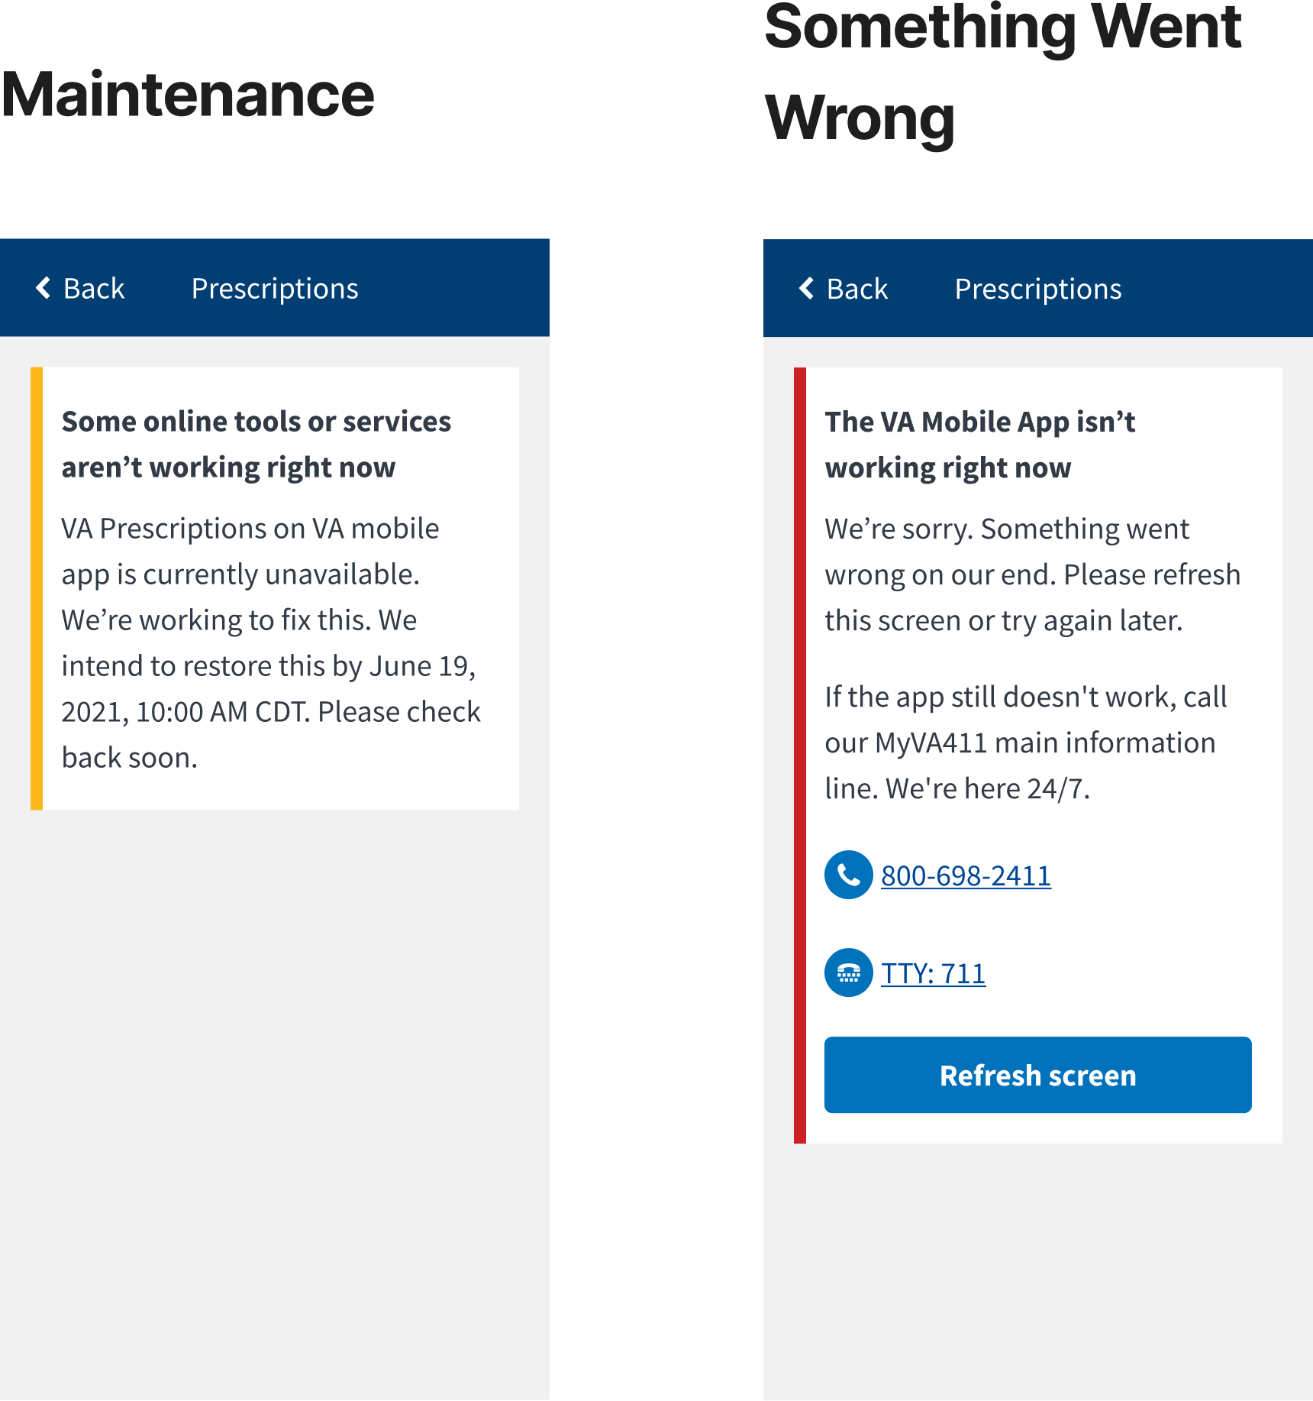

## 

**No Prescriptions**

Some users may not see a list of prescriptions. This may be due to the following:

1. They don’t have a premium MyHealtheVet account
2. They don’t have any active prescriptions, *or* their inactive prescriptions have been inactive for more than 180 days
3. Their prescriptions are controlled substances, self-entered, or were administered at a clinic or ER
4. Their prescription is new and has not been updated in upstream systems yet

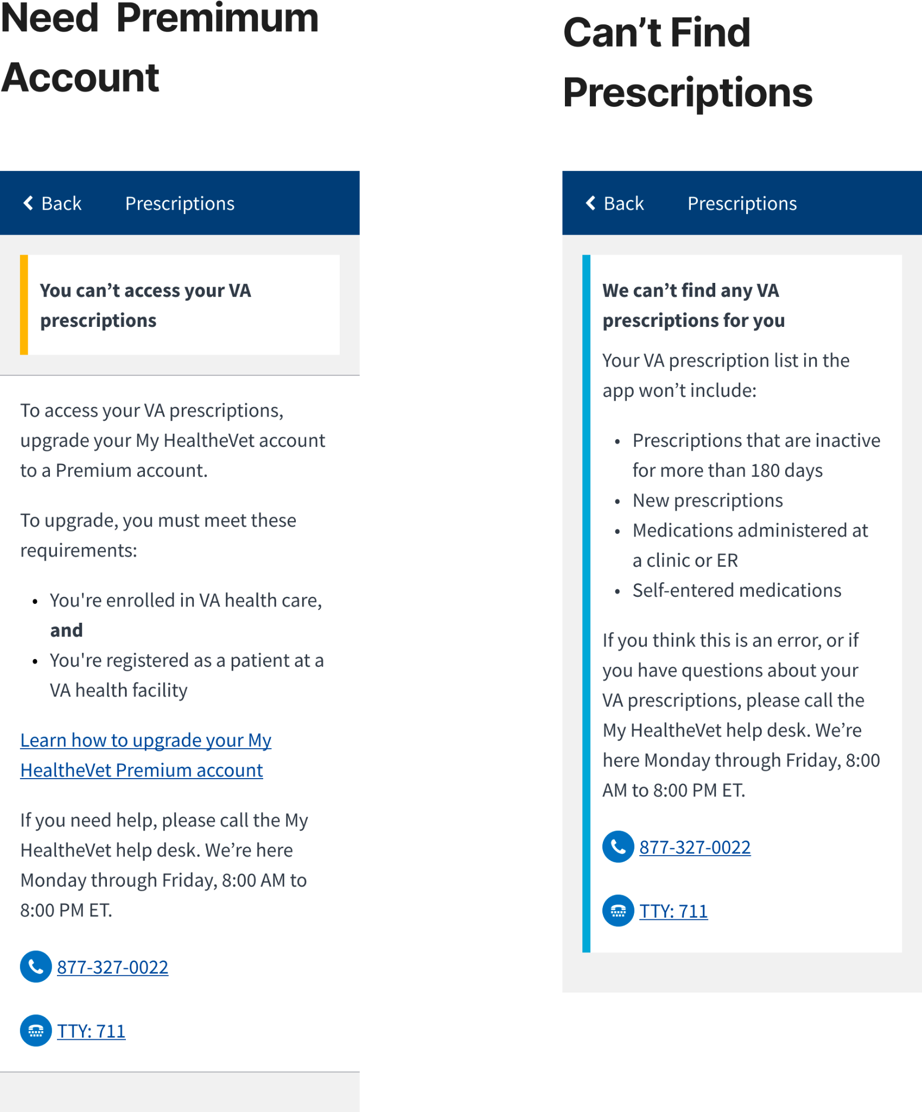

**Request Refills**

To request a refill of a prescription, users should:

1. Click the “Start refill request” button at the top of the “Prescriptions” screen
2. Click the prescriptions they want to refill in the “Refill Request” screen
3. Click the “Request refills” button at the bottom of the “Refill Request” screen
4. Click “Request Refill” in the confirmation screen (this will look different on iPhone and Android phones)

**The “Refill request” screen only lists refillable prescriptions. Prescriptions may not be refillable if:** the prescription does not have any remaining refills, the prescription was recently refilled or is currently in process of being refilled, or if it has expired/ discontinued. Users should consult the VA Pharmacy or their prescribing doctor if they believe there is an error with the prescriptions on this list.

They may also be able to determine the cause by looking at the prescription details for that prescription. (Go to the “Prescriptions” screen list, find the prescription in question, and select “Get prescription details”). This screen will include details such as the number of refills left and status, which may help them determine why a prescription is not refillable.

*Note: Prescription refills will be mailed to the address on file at the user’s local VA Pharmacy. Changing their address in the “Profile” section of the app will* ***not*** *change the delivery address. Users should contact their local VA Pharmacy if they want to verify or change their prescription address.*

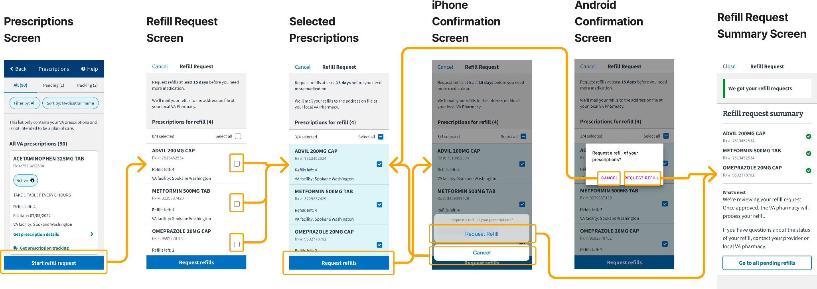

**“Refill Request Summary” Screen**

Once users have confirmed their refill request, they will be navigated to the “Refill request summary” screen, which states whether their requests have been successfully submitted. Successful requests will have a green checkmark next to them while unsuccessful requests will have a red “X” icon next to them.

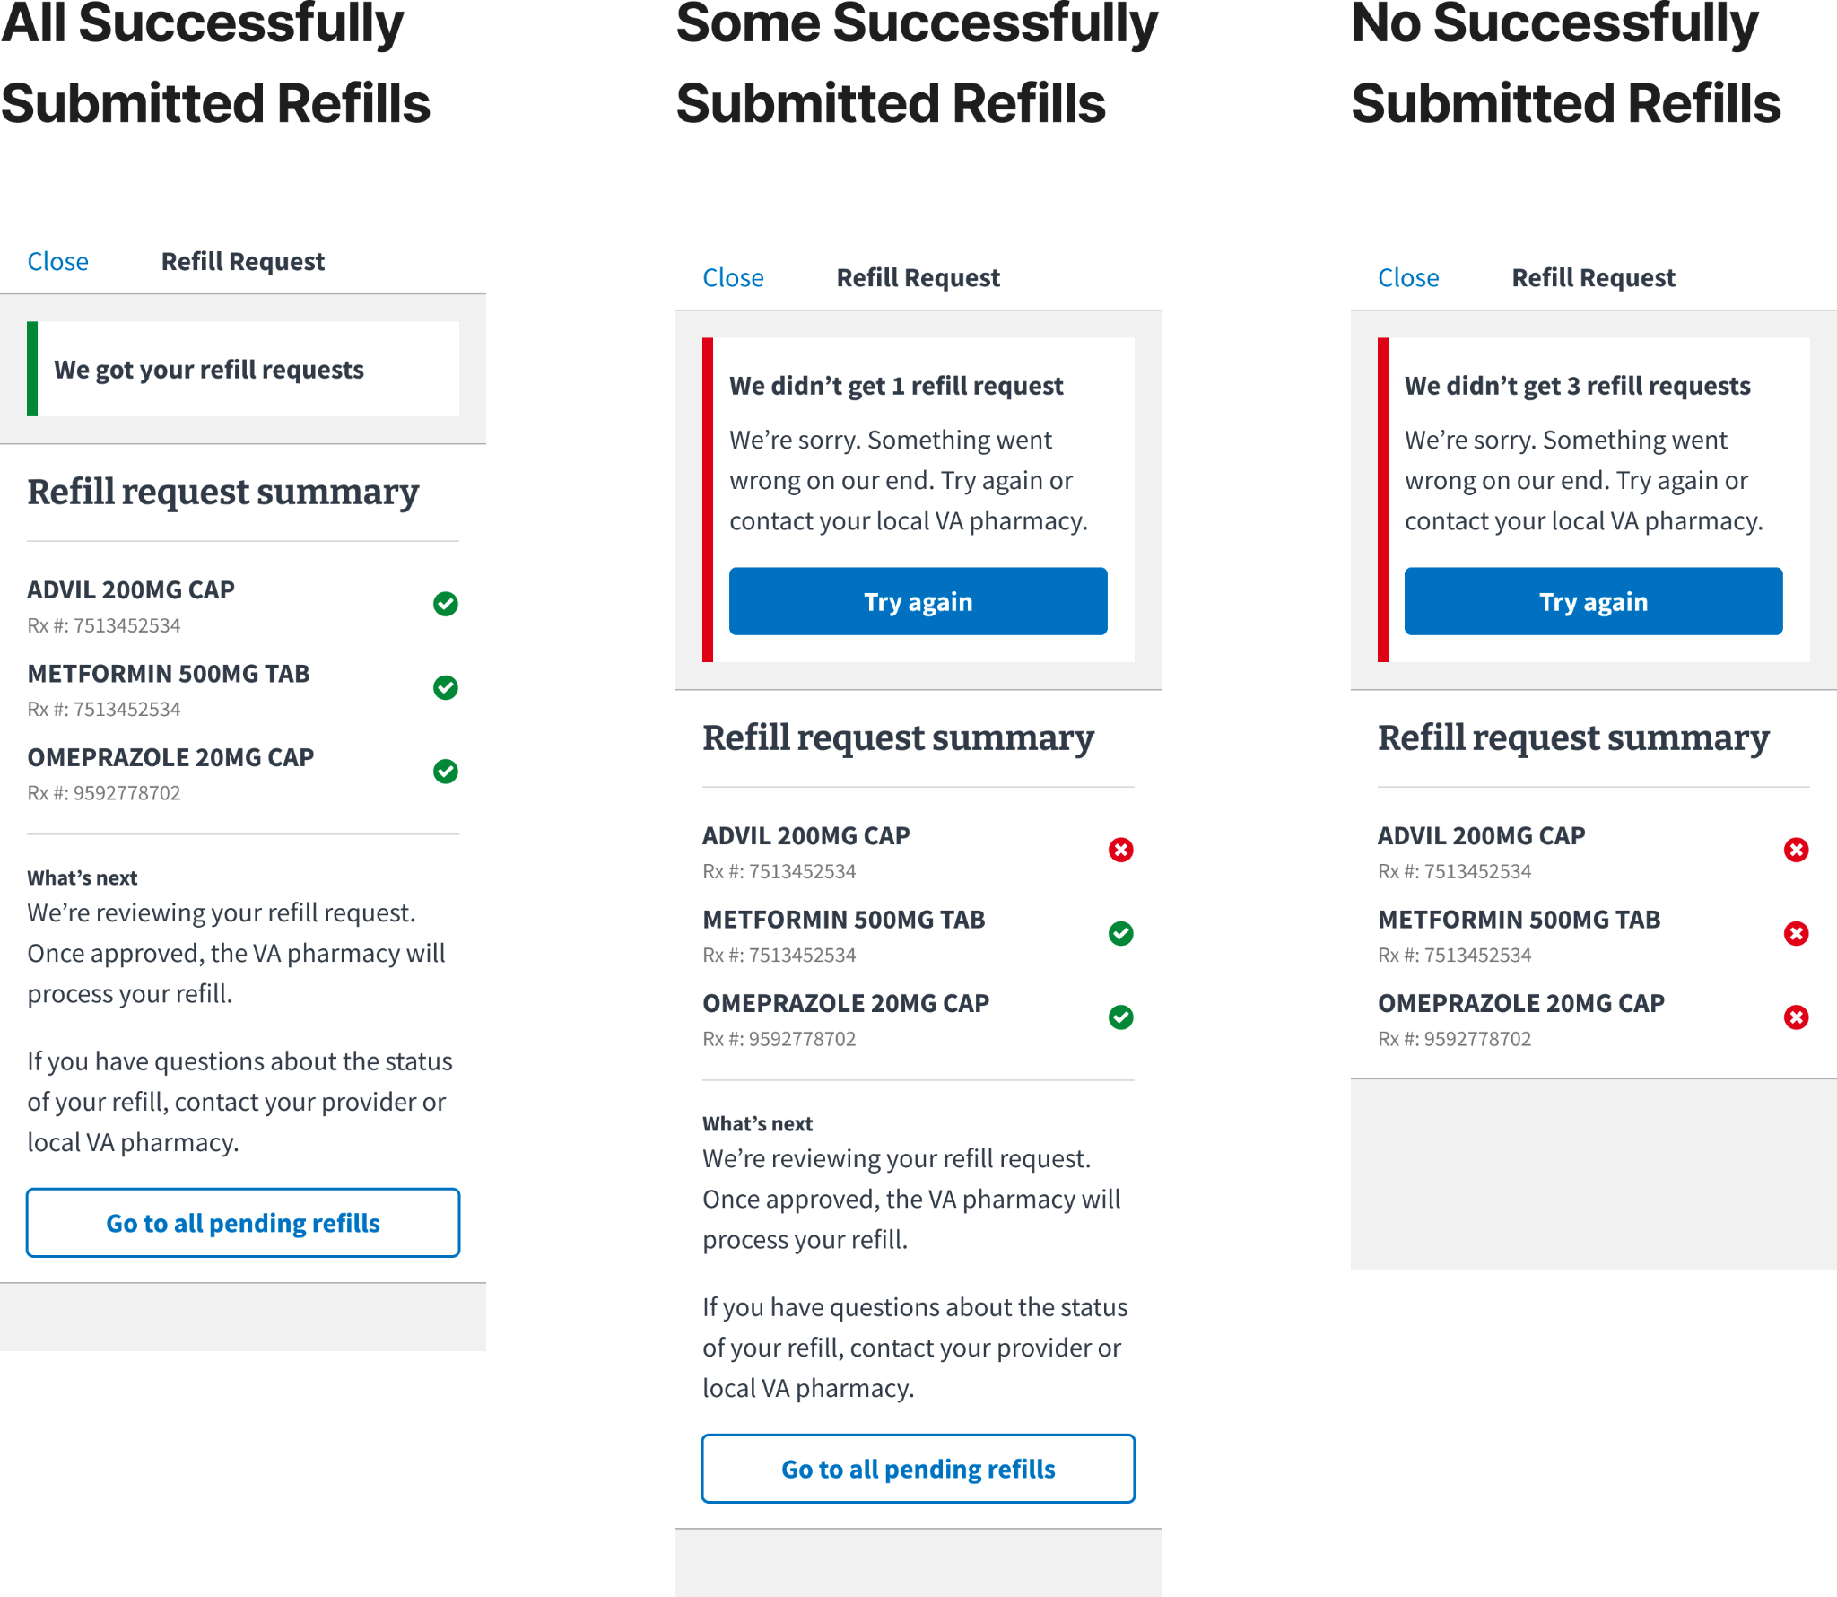

Users will receive an error message at the top of the screen when there are unsuccessful requests. Users should select the “Try again” button in the error message to resubmit the unsuccessful requests.

*Note: Once resubmitted, the summary screen will only list those prescriptions that were resubmitted.*

**Refill Submission Errors**

Users will receive an error message at the top of the screen if they try to click the “Request refills” button without having clicked on at least one prescription. To dismiss the error message, users should click on at least one prescription. This will then allow them to click the “Request refills” button and move forward with their request.

| **Refill Request Screen** | **Refill Error Message** |
| --- | --- |

**Prescription Details**

To see additional prescription details (such as quantity or fill date), users should click the “Get prescription details” button on any prescription card.

| **Prescriptions Screen** | **Prescription Details** |
| --- | --- |

*Note: If a prescription is refillable, a “Request refill” button will appear on the details screen, which users can also use to request that prescription’s refill.*

**Prescription Statuses**

To view the status definition of a prescription, users should select the status tag (on the prescription card or on the prescription details screen).

| **Prescription Screen** | **Prescription Details** | **Status Definition** |
| --- | --- | --- |

The prescription statuses and associated definitions are:

| **Active** | Prescription may be available to be refilled (can be refillable or non-refillable) |
| --- | --- |
| **Active: On Hold** | The pharmacy is reviewing the prescription before it can be filled |
| **Active: Parked** | The prescription has been filled but the doctor hasn’t issued it yet |
| **Active: Refill in Process** | The prescription is being processed or refilled by the pharmacy, or on the way to the user |
| **Active: Submitted** | A refill for the prescription has been requested |
| **Active: Suspended** | A prescription that is not scheduled to be filled yet |
| **Discontinued** | A prescription that is no longer available to be filled. |
| **Expired** | A prescription that is too old to be filled. This does not refer to the expiration date of the prescription |
| **Non-verified** | A pharmacist is verifying the prescription |
| **Transferred** | The facility that fills the prescription is now a Cerner facility |
| **Unknown** | The status of the prescription can not be determined |

*Note: Non-active prescriptions (expired, discontinued) are only displayed for 180 days following the date of expiration or discontinuation.*

**Filter & Sort**

Users can filter and sort the prescriptions list to help them find specific prescriptions.

To filter or sort, users should select the filter buttons that are below the tab bar.

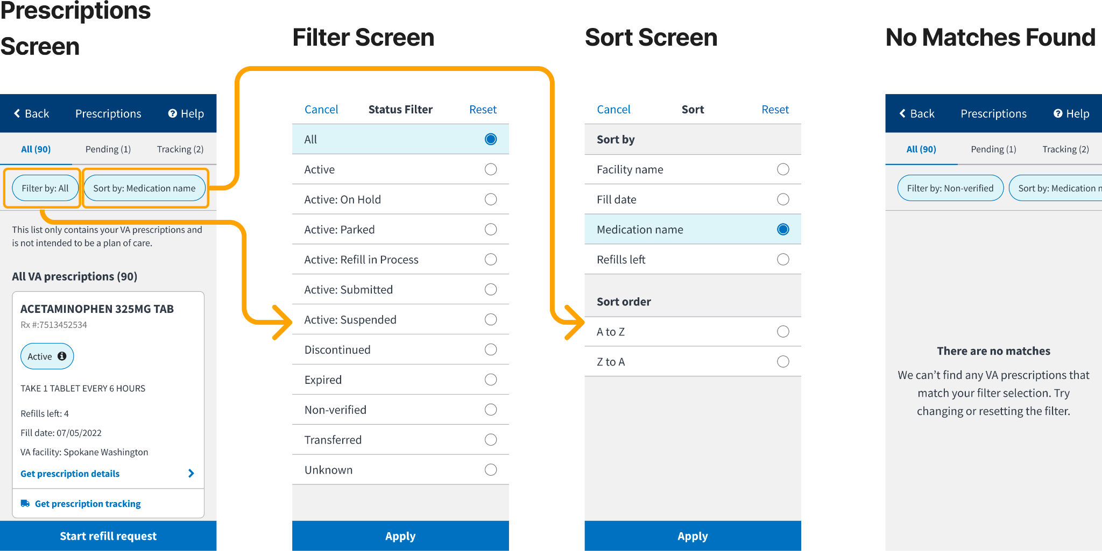

*Note: If users select a status from the filter screen, and they do not have a prescription with that status in the list, they will get a screen with a “There are no matches” message. Users should select another status from the list or reset the filter to view prescriptions.*

**Pending Prescriptions**

The “Pending” tab will list prescriptions that have recently been submitted (i.e. have a status of Active: Submitted) and prescriptions that are being processed by the VA pharmacy (i.e. have a status of Active: Refill in Process).

* Prescription refills may be in process for a few days, depending on how long it takes to be processed and shipped by the VA pharmacy

To see “pending” prescriptions, users can either click:

1. The “Pending” tab in the top tab bar
2. The “Go to all pending refills” button in the refill request summary screen

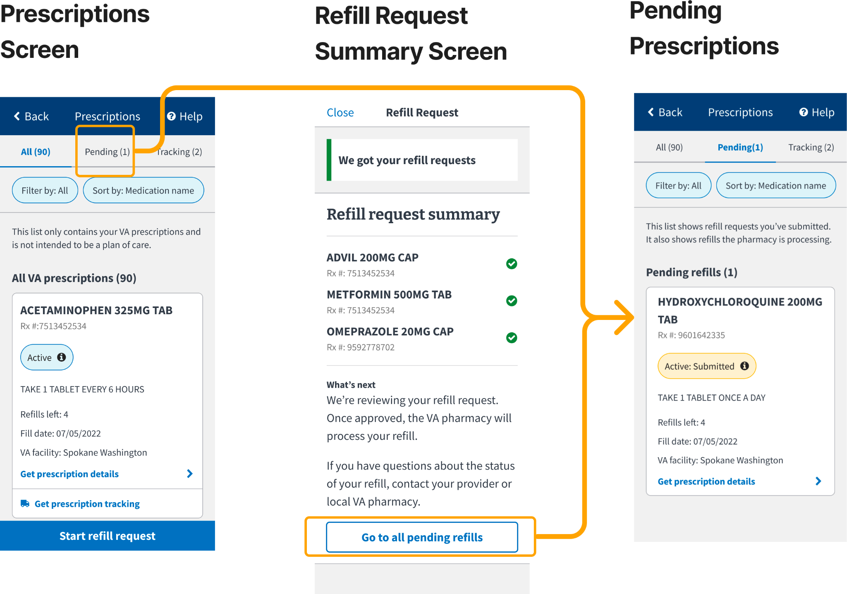

**Tracking Prescriptions**

To see “trackable” prescriptions, users can:

1. Click the “Tracking” tab in the top tab bar (easiest way)
2. Look for trackable prescriptions in the “All” tab - trackable prescriptions will have an additional button on the card that says “Get prescription tracking”

*Note: The “Tracking” tab will list prescriptions that have tracking information within the last 15 days (from tracking label creation date), even if it’s been delivered.*

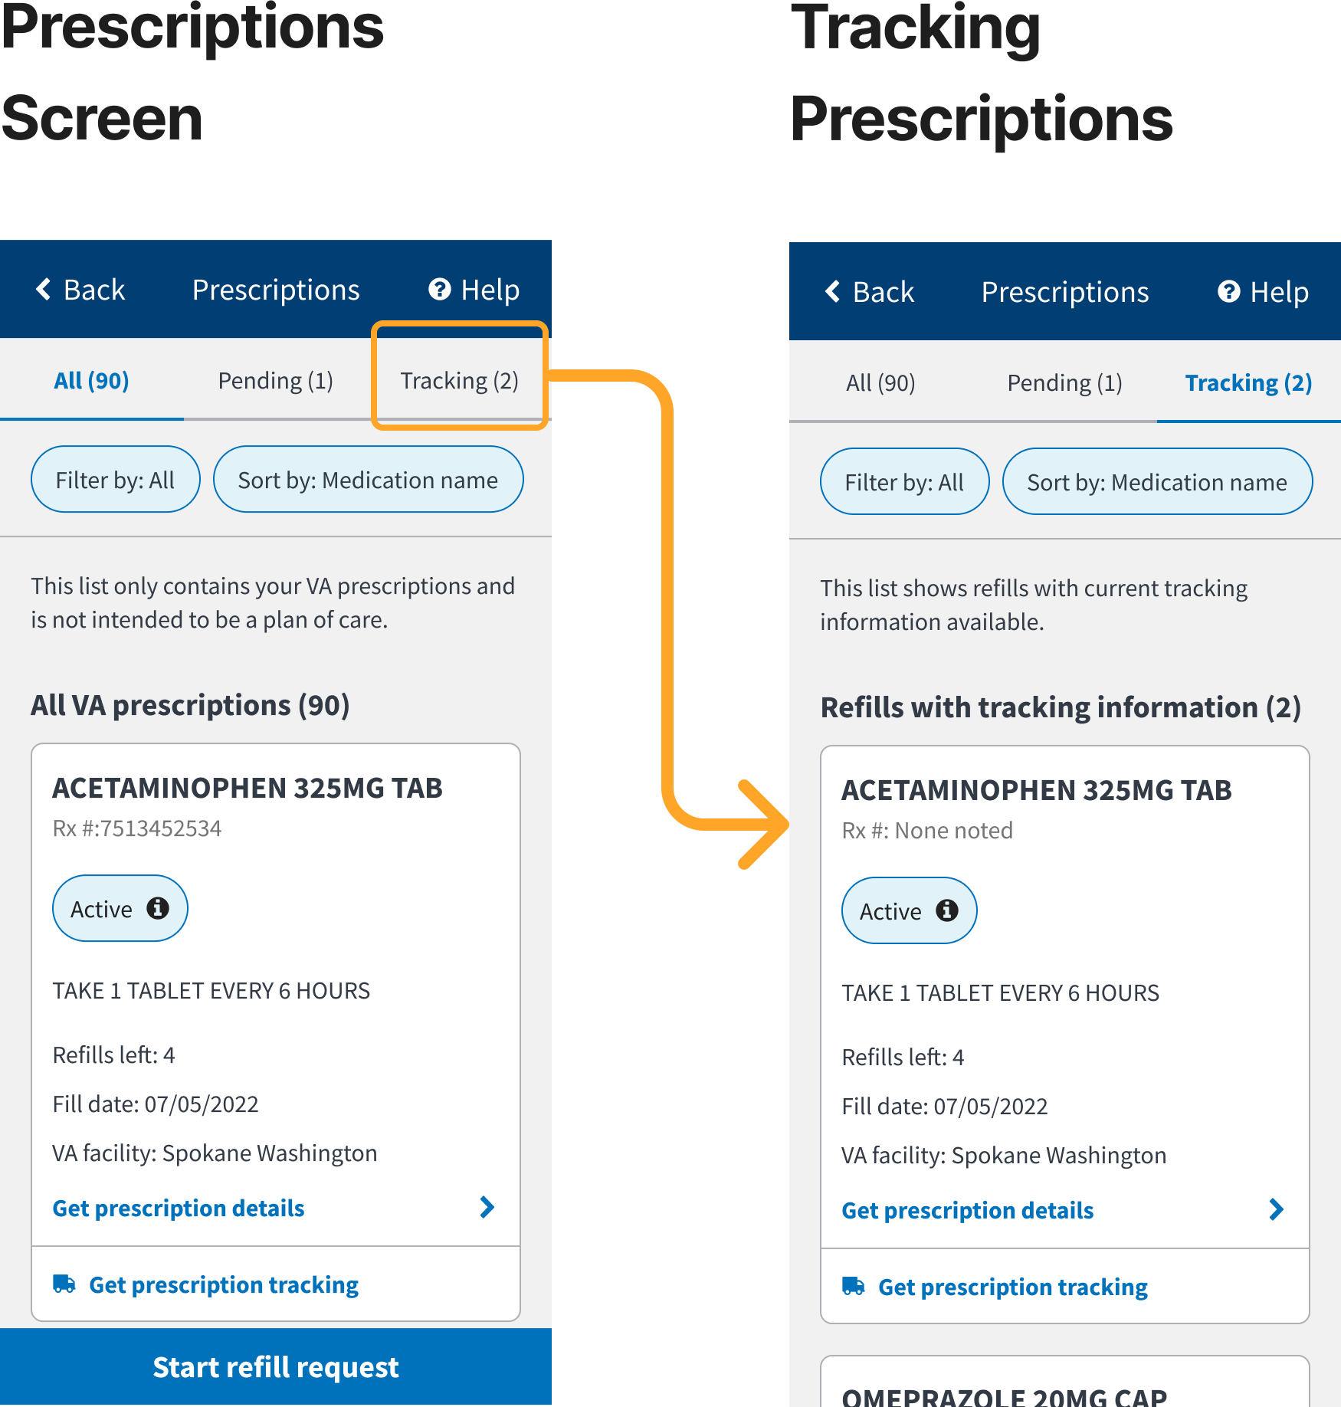

**Tracking Details**

To see tracking details, users should click the “Get prescription tracking” button on the prescription card for trackable prescriptions (these prescriptions can be found both in the “All” or “Tracking” tab).

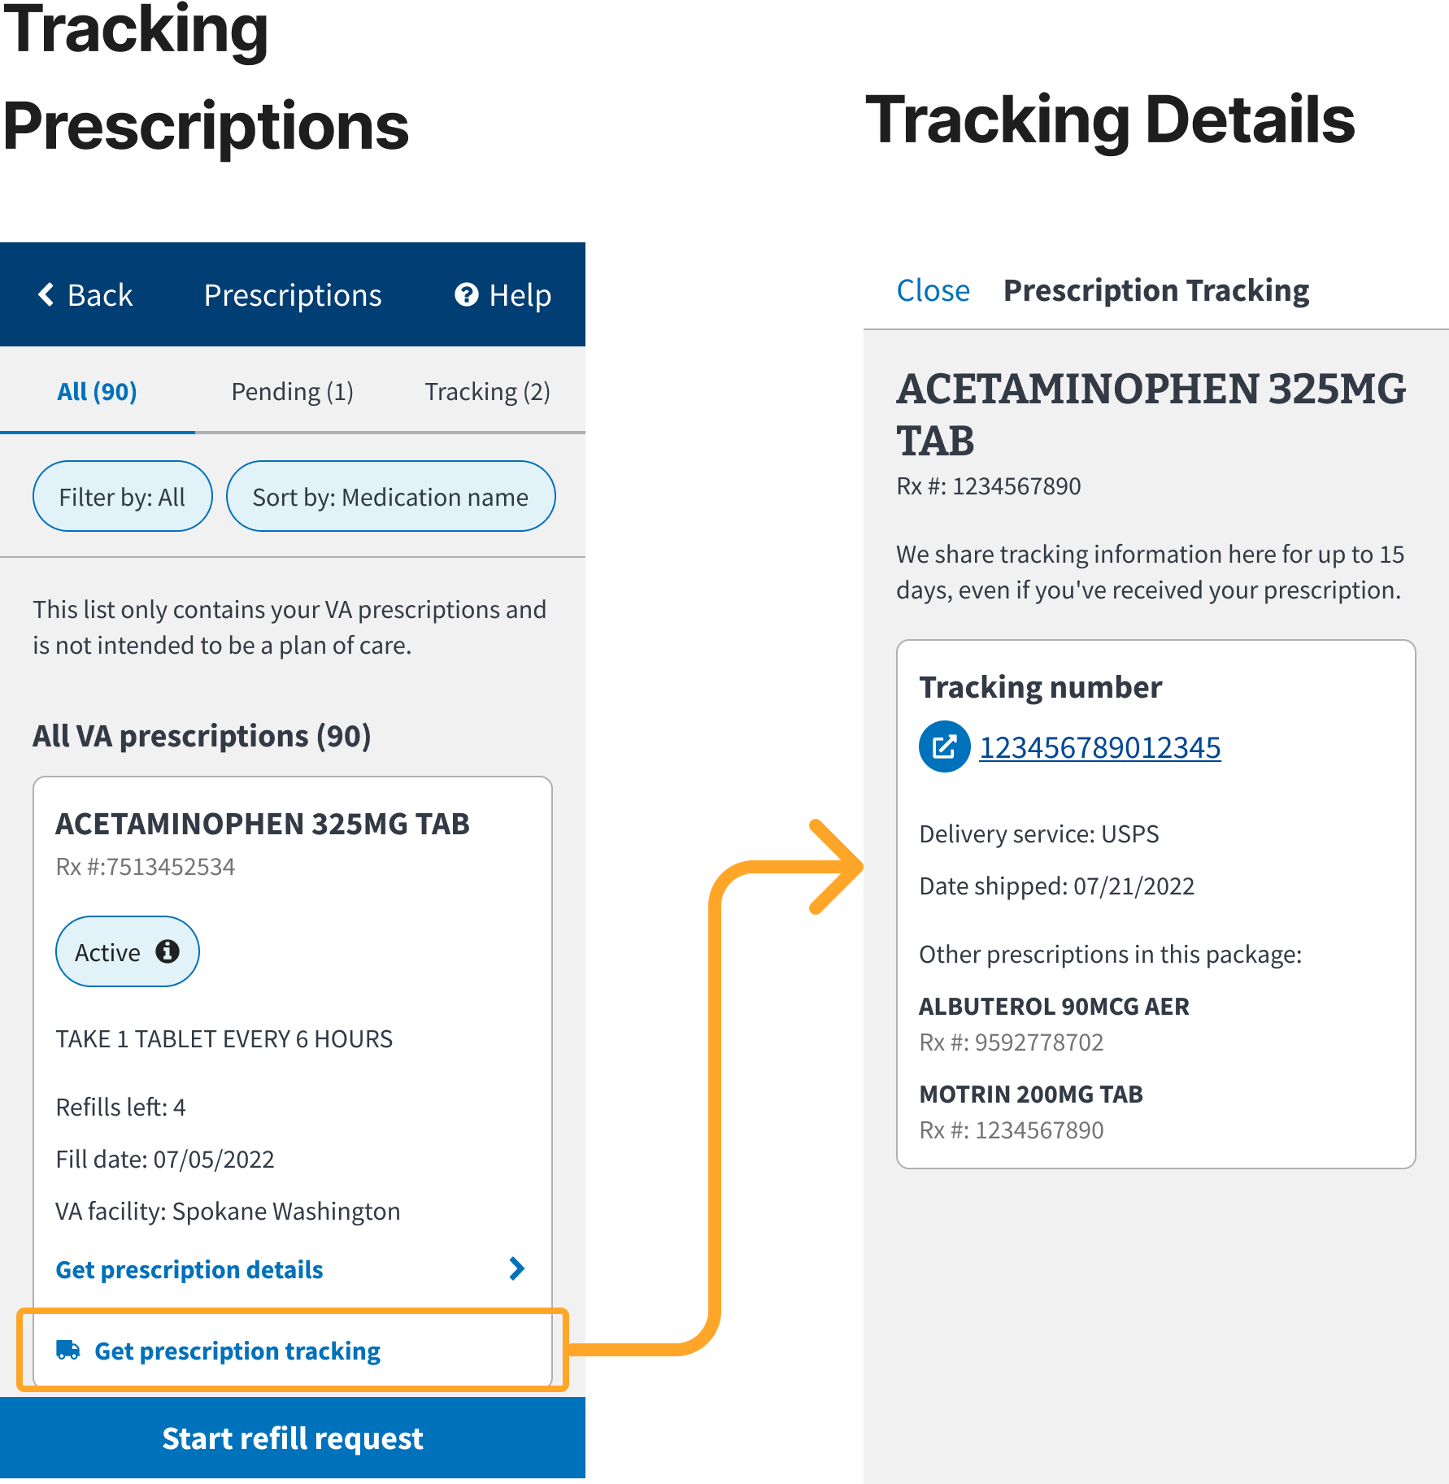

To see additional tracking information such as the last location or expected delivery date, users should click on the tracking number to be taken to the carrier site. *Please note that this information may not yet be available if the prescription just recently became trackable (i.e. the shipping label was created, but it has not shipped yet).*

**Multiple Tracking Numbers**

Some prescriptions may have multiple tracking numbers. This occurs when multiple batches of the same prescription have been sent within the same 15-day period. In those cases, multiple tracking cards (representing packages) will be shown in the tracking details screen (see screenshot below). The packages will be ordered from the most recent ship date to the oldest ship date.

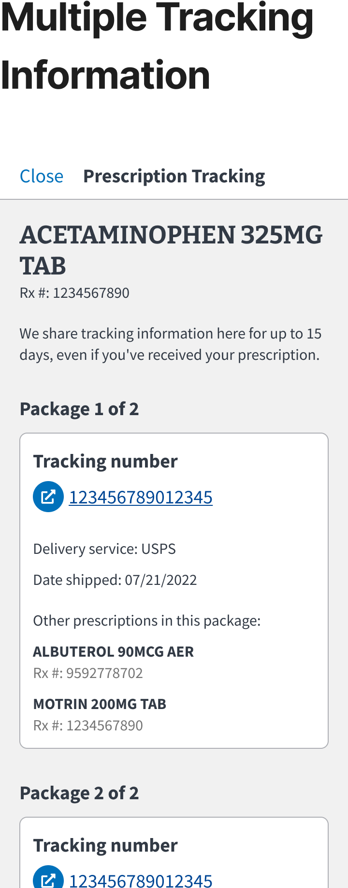

**Cerner**

Cerner prescriptions cannot be refilled through the app. If users have *any* prescriptions at facilities that have transferred to Cerner, they will see an alert banner in the prescriptions screen that says “We can’t refill some of your prescriptions in the app”. Users will still be able to manage their non-Cerner prescriptions. Users should select the “Go to My VA Health” link/button on the Prescription details page to manage and refill Cerner prescriptions. (See screenshots below.)

| **Prescription Screen** | **Prescription Details** |
| --- | --- |

#### **Appointments**

Within the app, users will be able to view confirmed upcoming and past appointments.

* Upcoming appointments will include all VA appointment types (including community care) over the next 365 days
  + This list will not include user-requested but currently unconfirmed appointments.
* Past appointments will include all appointment types from the past 365 days
* For all other appointment functionality (ex: scheduling, canceling), users must call or visit VA.gov.

To see appointments, users should click on the Health care card on the homepage screen, and then click the appointments card on the next screen.

| **Mobile App Homepage Screen** | **Healthcare Screen** | **Upcoming Appointments Screen** | **Past Appointments Screen** |
| --- | --- | --- | --- |

| **Upcoming Appointment Details** | **Cancelled Appointment Details** | **Past Appointment Details** |
| --- | --- | --- |

#### **Secure Messaging**

Secure Messaging (SM) on the mobile app is a limited version of the web based MHV experience. Within the mobile app, users can:

* View messages
* Reply to messages
* Compose and send a new message
* Compose a draft message
* Attach a file to a message
* View all folders (default and customer-created)
* Delete and move messages
* For all other secure messaging functionality, users must use MHV on the web

Noted differences between the app and web based MHV version of Secure Messaging:

* User Preferences
  + Users cannot manage their Secure Messaging preferences within the app.
  + Default user preferences or preferences customized on MHV will not carry over to the app in this first iteration. For example, the inbox of web users defaults to only display messages from the past 3 months. Within the app, this default does not apply, and all messages will display within the inbox.
* Folder Management
  + Users cannot create or delete custom folders. For this functionality, users must use MHV on the web.

To access Secure Messaging, users can click on the Health care card from the homepage screen, and then select Messages.

| **Homepage Screen** | **Health care Screen** | **Secure Messaging Inbox** |
| --- | --- | --- |

#### 

#### 

#### **VA Vaccine Records**

App users can review their VA vaccine records. Every vaccine provided to the user by VA is included in the user’s history, including the COVID-19 vaccine. Vaccine history updates every 36 hours; it does not include self-reported data.

When viewing the details of their vaccine, users can review:

* Date administered
  + Date the user received the vaccine
* Vaccine type
  + Type of vaccine the user received
* Type and dosage
  + This field will vary by vaccine type and includes a variety of information
* Series status
  + If the vaccine has multiple doses, this field will indicate where the user is in the series, such as 1 of 2 or 2 of 2.
* Provider
  + VA facility where the user received the vaccine
* Reaction
  + Comments from the provider about any reaction the user had to the vaccine
* Notes
  + Additional comments from the provider or additional details about the vaccine

| **Homescreen** | **Health care screen** | **VA vaccine list** | **VA vaccine details** |
| --- | --- | --- | --- |

#### **Letters**

App users can customize and download common VA letters and documents. Within the app, users will be able to:

* Edit address for letters
* Configure letters
* Download letters

To view letters, users should click on the Letters card on the app homepage screen. Users have an opportunity to add/update their mailing address before viewing their list of letters.

| **Homepage Screen** | **Letters Mailing Address Screen** | **Letters List Screen** |
| --- | --- | --- |

| **Letter Configuration  Screen (part 1)** | **Letter Configuration Screen (part 2)** | **Generated Letter** |
| --- | --- | --- |

#### **Payments**

App users will be able view past VA Payments

To view payment history and details, users should click on the Payments card on the app homepage screen.

When Viewing details of their payments, users can view

* Payment Date
* Payment Type (i.e Compensation & Pension, GI Bill, etc)
* Payment Amount
* Payment Method (i.e Direct Deposit or Paper Check)
* If Payment Method is a direct deposit user will see additional information
  + Bank - Financial Institution where funds were deposited
  + Account - last 4 digits of the account number where the funds were deposited
* Troubleshooting links to assist with questions or concerns about payments
  + What if my payment information doesn’t look right?
  + What if I am missing a Payment?

| **Homepage Screen** | **Payments Screen** | **Payment Details Screen** | **Troubleshooting links**    **What if I am missing a Payment?** |
| --- | --- | --- | --- |

#### **General Errors**

Depending on the error and the functionality, users may be directed to one of two contact support centers. Below outlines which functionality each contact support center handles:

* HRC
  + Prescriptions
  + Appointments
  + Secure Messaging
* VEO Tier 1 Contact Center
  + Login
  + Claims
  + Profile
  + VA Vaccine Records
  + Facility Locator
  + Veterans Crisis Line
  + COVID tools
  + Payments

| **Error** | **Where would the user see this?** | **Message displayed to the user** |
| --- | --- | --- |
| Claims, Profile or Vaccine records feature is down | When a user clicks into the Claims card or icon and/or Profile icon. |  |
| The Letters feature is down | When a user clicks into the Letter card on the mobile app homepage. |  |
| A user is missing EDIPI | When a user attempts to access Claims, this screen would display in place of the Claims landing page. |  |
| A user has never used claims. | When a user clicks the Claims card/icon within the app. |  |
| A user does not have an MHV premium account and cannot access Secure Messaging. | When clicking into Secure Messaging on the app.  The upgrade link takes the user to the MHV web upgrade flow. |  |
| The Secure Messaging feature is down. | Appears when clicking into Secure Messaging on the app. |  |
| A message failed to send. | Appears when sending a message within Secure Messaging on the app. |  |
| A message cannot be found. | Appears when the user views a message that cannot be found and loaded into the app. |  |
| Messages are not loading. | Appears when a user tries to access the inbox or any folders. |  |

#### **Known Issues**

| **Error** | **Where would the user see this?** | **Screenshot of Error** | **Resolution** |
| --- | --- | --- | --- |
| Wi-Fi Error | Users may see this upon logging into the app. |  | Users will need to turn off their Wi-Fi and switch to utilizing their phone data. |
| MHV Login Scrolling Problem | Users may encounter a problem where they can hit “done” before entering their password. |  | Users will need to scroll down to see the password field. |
| Google sign in via ID.me fails | Users will be unable to sign into the app using Google via ID.me |  | Users will need to log in with their ID.me credential directly or use a different credential type (MHV or DS Logon). |

## **Contact Center Escalation Path**

Here is the expected escalation path for when an issue arises from support calls:

* VEO Tier 1 Contact Center
  + If the issue cannot be resolved, a ticket will be created on GitHub.
  + If there is a complete outage or a security breach, the VA mobile product team (Chris Johnston, Matt Hall, Meko Hong) will be tagged in Slack via a direct message or #va-mobile-app-alerts channel
* HRC Contact Center
  + If the issue cannot be resolved with the user on the phone, a ticket will be created in MS Dynamics
  + If there is a complete outage or a security breach, an email will be sent to the MHV distribution list, monitored by the VA mobile app team.